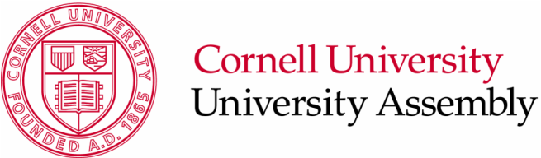
109 Day Hall
Ithaca, NY 14853
p. 607.255.3175
f. 607.255.2182
e. assembly@cornell.edu
w. http://assembly.cornell.edu

Agenda
University Assembly Codes and Judicial Committee
March 18th, 2016
9:00-10:00am
305 Day Hall
- Call to Order (Chair)
  - Call to Order (1 minute)
- Approval of Minutes (Chair)
  - February 2, 2016 (1 minutes) ^{[1]}
  - March 1, 2016 (2 minute) ^{[2]}
- Business of the Day
  - Announcement: UHRB Applications [G. Kaufman] (5 minutes)
  - OSWG Recommendations for Campus Codes [G. Kaufman] (20 minutes) ^{[3] [4]}
  - Reviewing UHRB Application Process in Campus Code [G. Kaufman] (15 minutes) ^{[5]}
  - Interim Measures Recommendations for Campus Code [G. Kaufman] (15 minutes) ^{[6]}
- Adjournment
  - Adjournment (1 minute)

Attachments
- February 2, 2016 Minutes
- March 1, 2016 Minutes
- Outdoor Space Working Group Final Report and Recommendation
- Outdoor Space Working Group Recommendation Campus Code of Conduct
- Draft: Reviewing UHRB Application Process in Campus Code of Conduct
- Draft: Interim Measures Recommendations for Campus Code of Conduct

