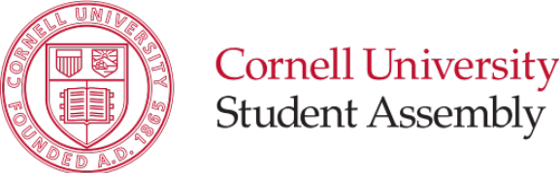
S.A. Resolution #3
Approval of the 2016-2017 Operating Budget
Originally Presented on: | (08/25/16)
Type of Action: | Internal Policy
Status/Result: | New Business

ABSTRACT: This is the Operating Budget for the SA 2016-2017 Academic Year.

Sponsored by: Diana Li ’17, Matt Indimine ‘18

Whereas, The Student Assembly Vice President for Finance is charged with the responsibility of updating the Student Assembly’s Operating Budget every academic year,

Be it therefore resolved, that the Student Assembly approve and adopt the Operating Budget for the 2016-2017 Academic Year attached as an appendix to this resolution.

Respectfully Submitted,

Diana Li ‘17
VP Finance, Student Assembly

Matt Indimine ‘18
EVP, Student Assembly

(Reviewed by: EXECUTIVE COMMITTEE, 8/23/16)

Appendix:

